**WebDriver Installation and Integration in Eclipse**

**HelloWorldSelenium.java:**

**package** com.ecommerce.test;

**import** org.openqa.selenium.WebDriver;

**import** org.openqa.selenium.chrome.ChromeDriver;

**public** **class** HelloWorldSelenium {

**public** **static** **void** main(String[] args) **throws** InterruptedException {

WebDriver driver = **new** ChromeDriver();

String baseUrl = "https://www.google.com";

driver.get(baseUrl);

System.***out***.println("Title of webappp " + driver.getTitle());

Thread.*sleep*(1000);

driver.close();

}

}

**Add external jar file in class path**

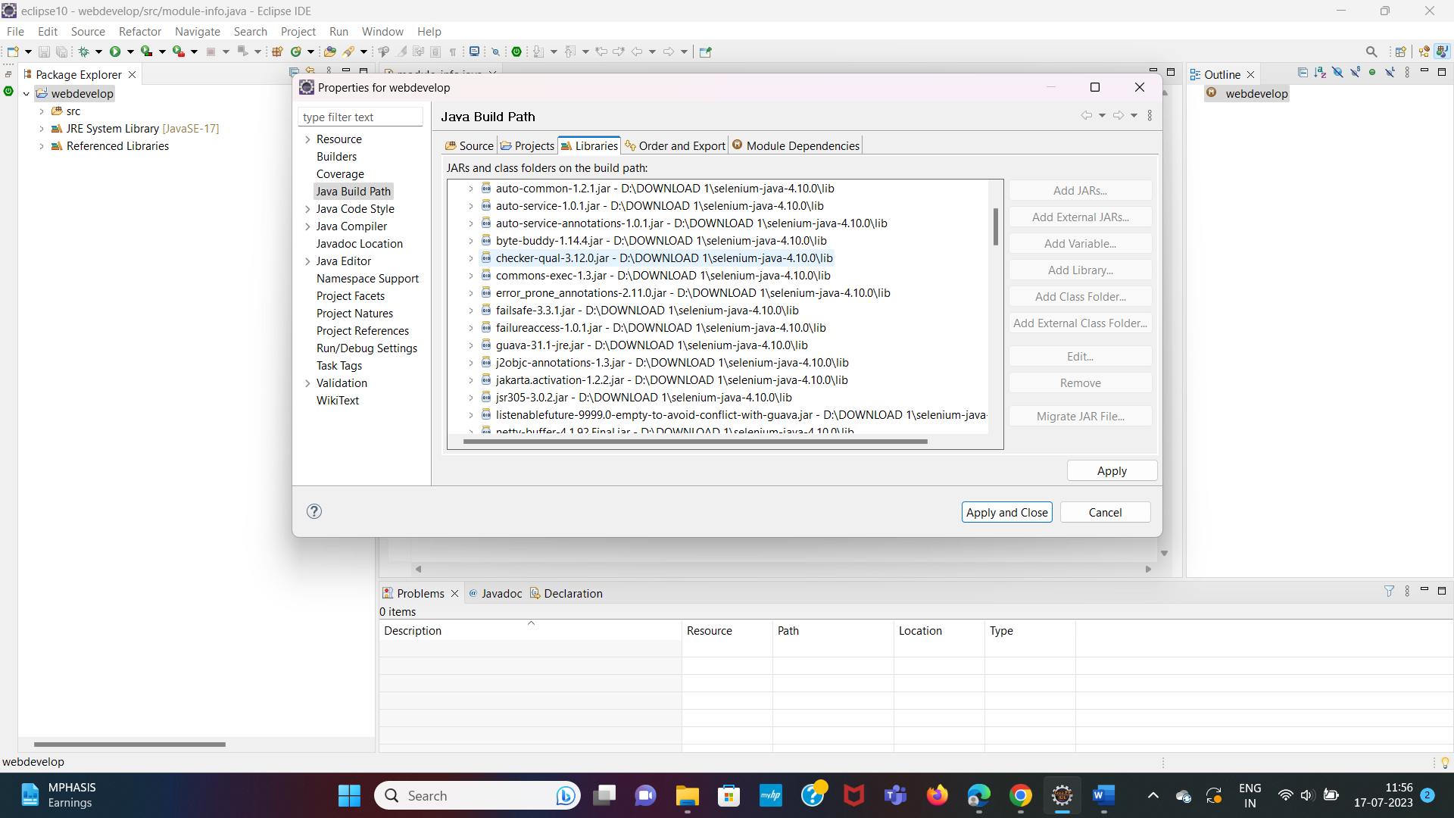

**Output:**

